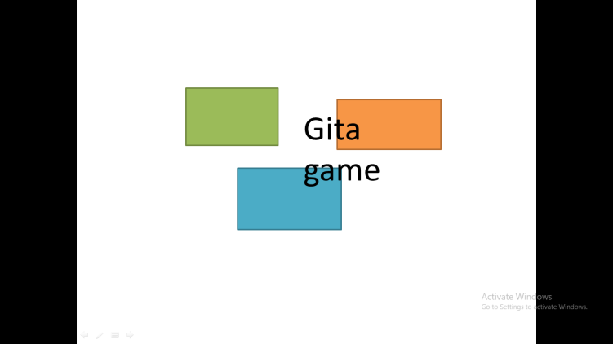

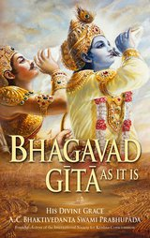

An open-source project

Gitagame doc

Going to contain documentation for all the versions

Omm prakash das

Omm prakash das

Code writer and book writer

Gitagame version 2.7

So gita game is a game which helps you learn bhagbat gita from a python based command line

App

This is the earliest releasable version 2.7 first released in ***17 ‎May ‎2024***

This game has only like a 5 to 6 question which only covers till preface the next version will

Continue

With the introduction parts

THIS GAME WORKS WITH THE POWER OF 2 SEPARATE PYFILES:

These pyfiles helps to run the game

One file handles the main game and the second file handles the player

The first file helps in running the main game when clicked the game

Begins . While the second files keeps the player data (data resets after

Quitting the game) this is a class file which handles the object oriented

Programing data base

|  |
| --- |
| class bhaktisystem:      def __init__(self,player,bhaktimeter):          self.player = player          self.bhaktimeter = bhaktimeter |

This was the main class that defines a player

So you know this game was developed on python which is a

High – level programing language which can be used in machine

Learning, AI, websites, mechatronics , etc.

**That’s it for version 2.7**

The time module helps us stop the program .

And the winsound just helps us play different sounds

Just to be specific the bhaktisystem module is just a outer class that you have seen in page 2 this helps in the points

The game was made from 3 modules which

Makes the game interesting the three modules are:

* Time
* Winsound
* bhaktisystem

Modules

2.7 main frame work

Gita game version 3.0